EXPERIMENT 1: BASIC CELLULAR COMMUNICATION SYSTEM USING FIGMA
AIM:
To design an interactive diagram illustrating the components of a basic cellular communication system using Figma.
SOFTWARE REQUIRED:
Figma (Web-based design tool).
PROCEDURE:
- Open Figma and create a new design file.
- Create a desktop frame of size 1440 × 900 pixels.
- Add the title “Basic Cellular Communication System”.
- Create cards for the five main components: Mobile Station (MS), Base Transceiver Station (BTS), Base Station Controller (BSC), Mobile Switching Centre (MSC), and External Network.
- Add suitable icons, colors, and short descriptions for each component.
- Connect the cards using directional arrows to represent communication flow.
- Use the Prototype feature to connect the cards to their respective detail screens or overlays, with Back buttons to return to the main diagram.
- Preview the design using the Present button and verify the interactions.

DESIGN
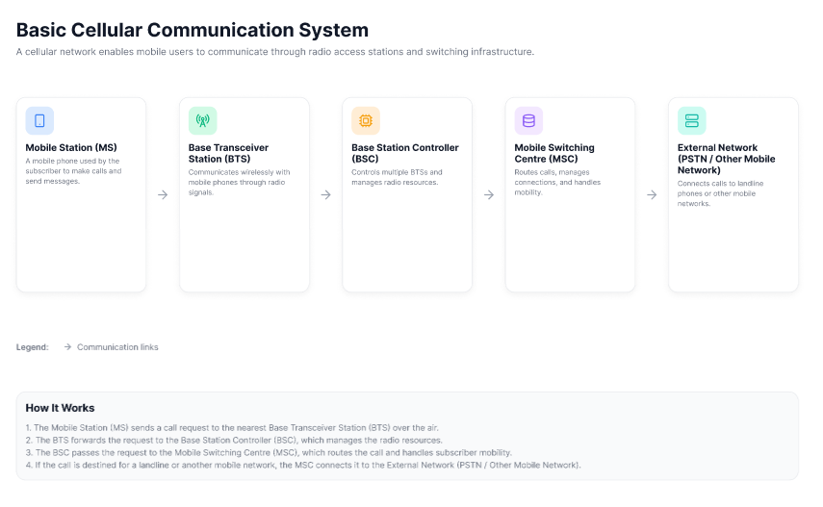
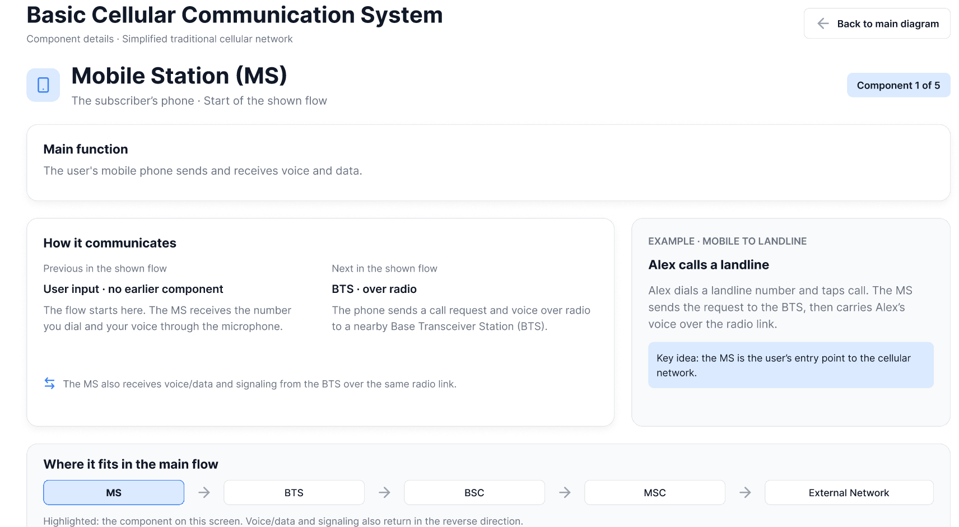
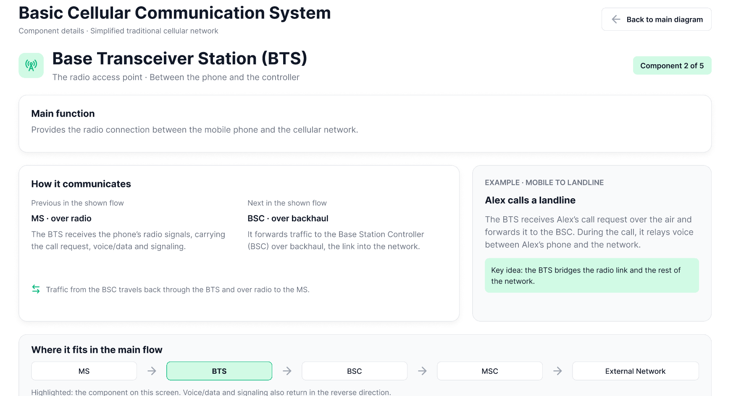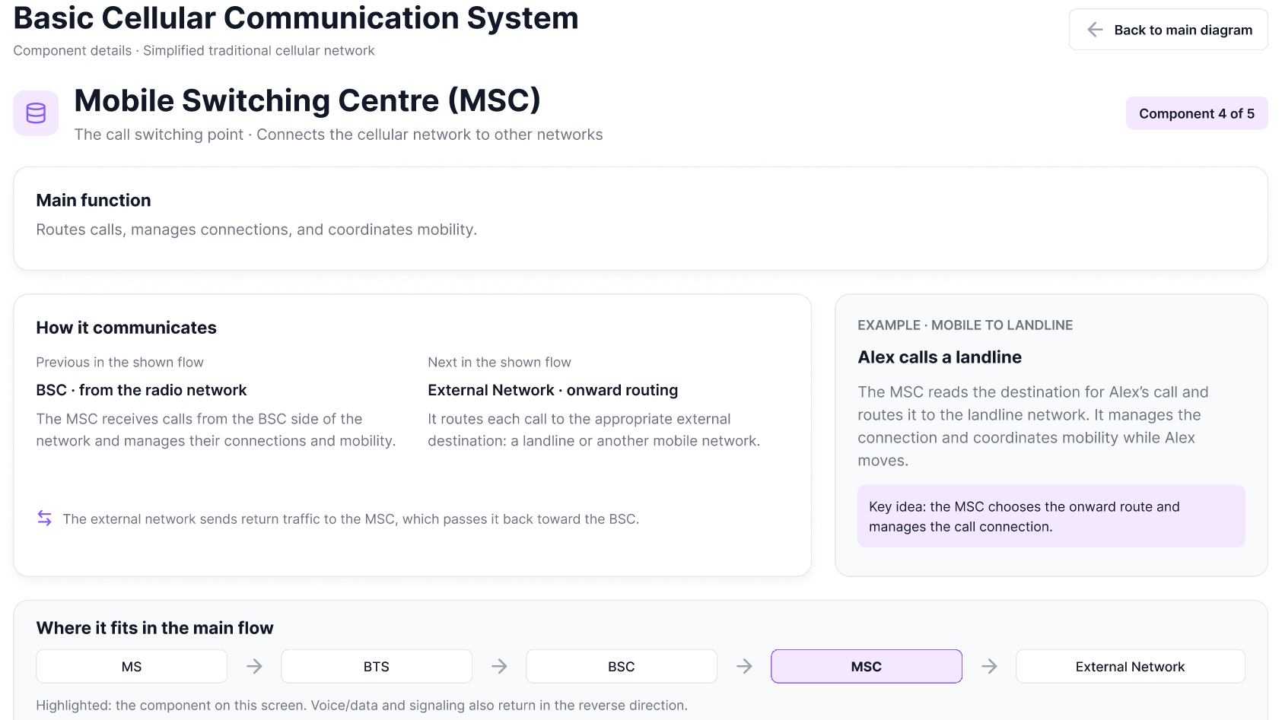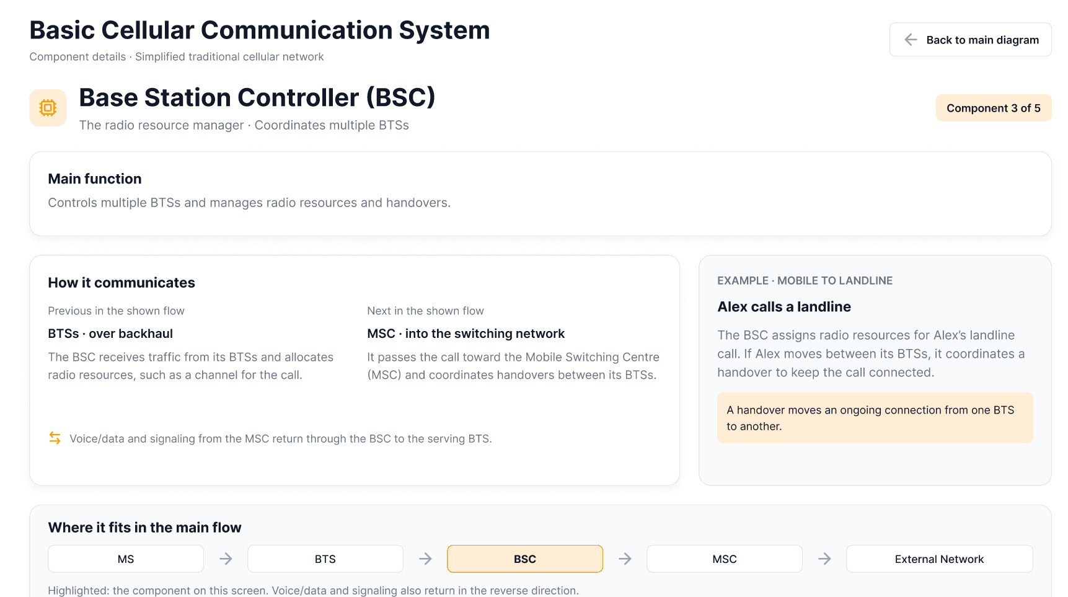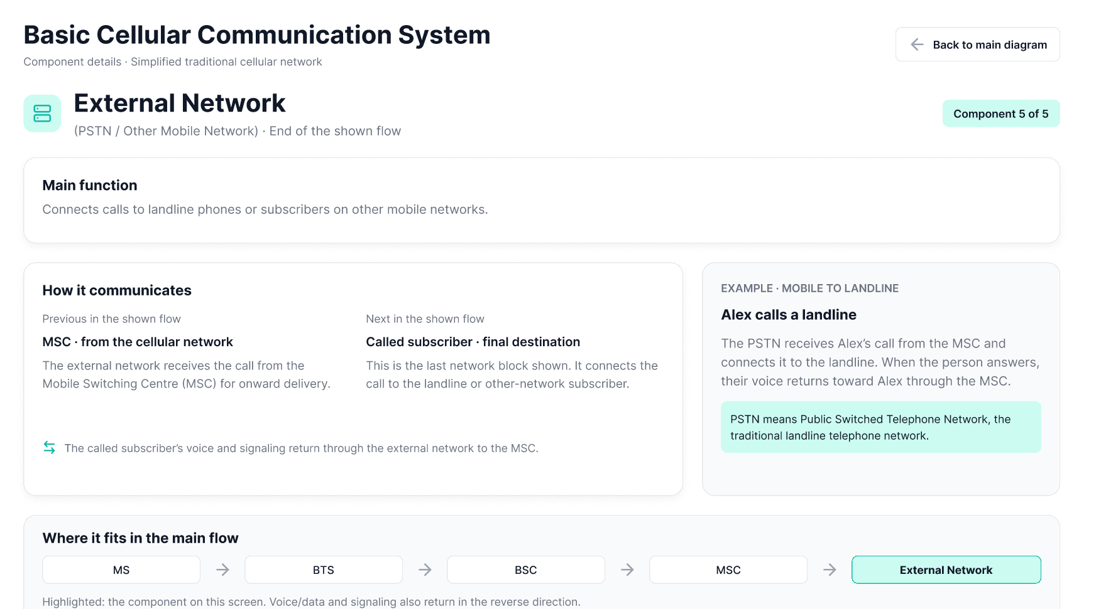

PROTOTYPE:
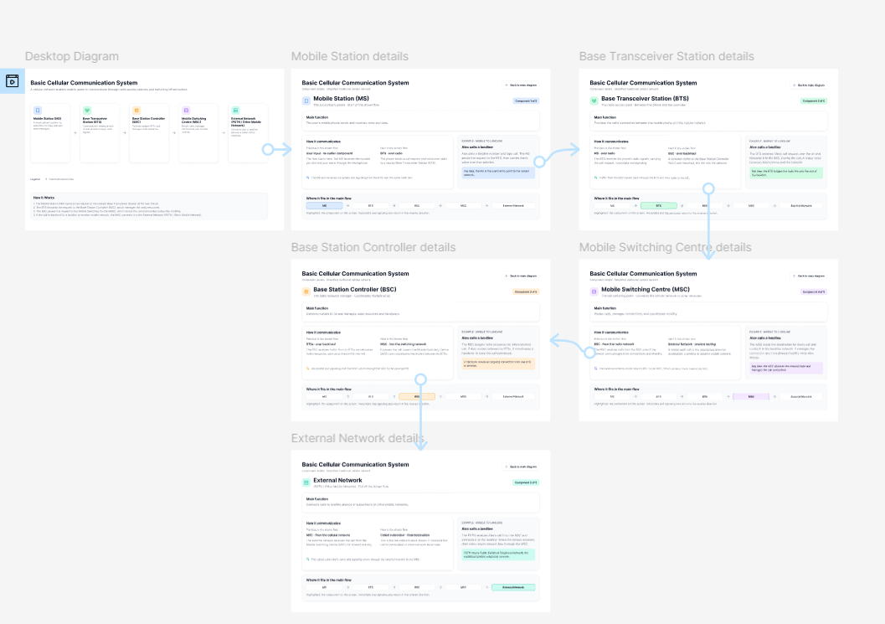
OUTPUT:
A cellular communication system diagram showing five major components connected in sequence, with descriptions and prototype interactions.
RESULT:
The basic cellular communication system diagram was designed in Figma, illustrating the components and their communication flow. Interactive navigation was planned using the Prototype feature.

